If you've looked on your NSLDS record, you may have seen the phrase 'SULA ELIGIBLE.' But what is SULA? And what does it mean to you? SULA is an acronym that stands for Subsidized Usage Limit Applies, and it refers to the new regulation that limits the amount of time (measured in academic years) a student may receive Direct Subsidized Loans. This time limit does not apply to Direct Unsubsidized Loans or Direct PLUS Loans.
The regulation applies to students who are considered first-time borrowers on or after July 1, 2013. If this limit applies to you, you may not receive Direct Subsidized Loans for more than 150 percent of the published length of your program. This is called your “maximum eligibility period.” Your maximum eligibility period is generally based on the published length of your current program. You can usually find the published length of any program of study in your school’s catalog.
For example, if you are enrolled in a four-year bachelor’s degree program, the maximum period for which you can receive Direct Subsidized Loans is six years (150 percent of 4 years = 6 years).
Because your maximum eligibility period is based on the length of your current program of study, your maximum eligibility period can change if you change to a program that has a different length. Also, if you receive Direct Subsidized Loans for one program and then change to another program, the Direct Subsidized Loans you received for the earlier program will generally count toward your new maximum eligibility period.
Certain types of enrollment may cause you to become responsible for the interest that accrues on your Direct Subsidized Loans when the U.S. Department of Education usually would have paid it. These enrollment patterns are described below:
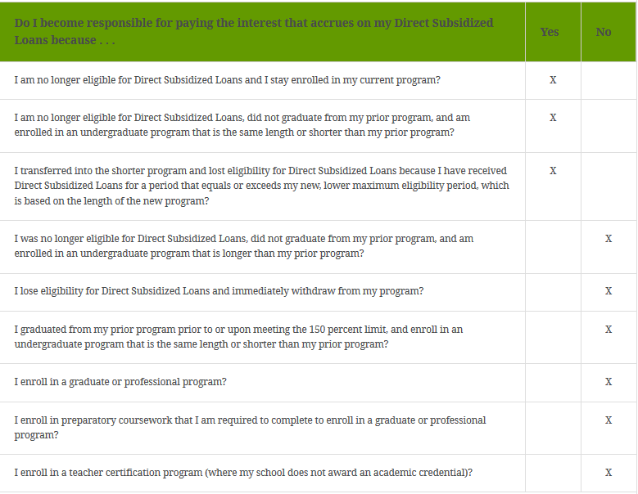
Again, you will be affected by the SULA regulation only if you had no student loan indebtedness on July 1, 2013 or you have no student loan indebtedness at the time you enroll in school after July 1, 2013. If this is you, the Department of Education will track your enrollment, the length of the program in which you are enrolled and the number of academic years in which you borrow a Direct Subsidized Loan. If you do not complete your program within 150 percent of the length of the program, then you may lose the interest subsidies on your subsidized loan(s) and your interest may begin to accrue as though it were an unsubsidized loan.
If you are affected by the SULA regulation, it doesn't mean you are eligible for additional awards; it does mean that you are being tracked to determine if you complete your degree program in 150 percent of the length of the program. For your benefit, you should complete in that timeframe.

